Version History

|  |  |
| --- | --- |
| 1.0 | Added mappings for Prod-Landing template |
|  |  |
|  |  |
|  |  |

English Page Path: /content/en/us/solutions/service-provider/index

­­­­­­­­­­­­­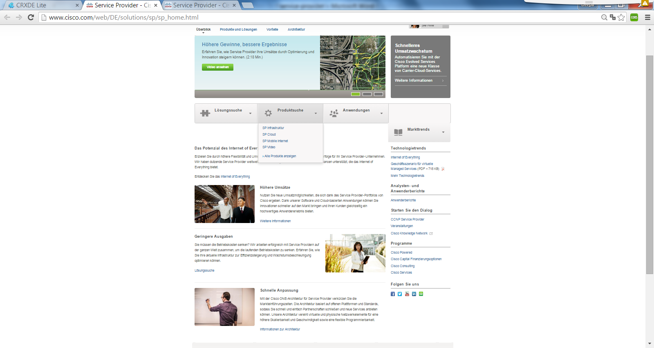

13

12

11

10

9

8

7

5

6

4

2

3

1

13

|  |  |  |  |
| --- | --- | --- | --- |
| 1 | /content/<locale>/solutions/<product-category>/index/jcr:content/content_parsys/overview*/layout-overview*/gd12v2*/gd12v2-left*/hero_large*/heropanel*/title |  | div.c50-pilot  getElementByTag(“h2”) |
| 2 | /content/<locale>/solutions/<product-category>/index/jcr:content/content_parsys/overview*/layout-overview*/gd12v2*/gd12v2-left*/hero_large*/heropanel*/ description |  | div.c50-pilot  getElementByTag(“p”) |
| 3 | /content/<locale>/solutions/<product-category>/index/jcr:content/content_parsys/overview*/layout-overview*/gd12v2*/gd12v2-left*/hero_large*/heropanel*/ linktext |  | div.c50-pilot  getElementByTag(“b”)  getElementByTag(“a.href”) |
| 4 | /content/<locale>/solutions/<product-category>/index/jcr:content/content_parsys/overview*/layout-overview*/gd11v1*/gd11v1-mid*/selectorbarfull*/selectorbarpanel*/title |  | div.c58-pilot  getElementByTag(“h2”) |
| 5 | /content/<locale>/solutions/<product-category>/index/jcr:content/content_parsys/overview*/layout-overview*/gd11v1*/gd11v1-mid*/selectorbarfull*/selectorbarpanel*/panelitems |  | div.menu  getElementByTag(“li”) |
| 6 | /content/<locale>/solutions/<product-category>/index/jcr:content/content_parsys/overview*/layout-overview*/gd11v1*/gd11v1-mid*/selectorbarfull*/selectorbarpanel*/alllinktext  /content/<locale>/solutions/<product-category>/index/jcr:content/content_parsys/overview*/layout-overview*/gd11v1*/gd11v1-mid*/selectorbarfull*/selectorbarpanel*/alllinkurl |  | div.menu  getElementByTag(“a”)  getElementByTag(“a.href”) |
| 7 | /content/<locale>/solutions/<product-category>/index/jcr:content/content_parsys/overview*/layout-overview*/gd12v2*/gd12v2-left*/spotlight_large_v2*/title |  | div.c11-pilot  getElementByTag(“h2”) |
| 8 | /content/<locale>/solutions/<product-category>/index/jcr:content/content_parsys/overview*/layout-overview*/gd12v2*/gd12v2-left*/spotlight_large_v2*/ description |  | div.c11-pilot  getElementByTag(“p”) |
| 9 | /content/<locale>/solutions/<product-category>/index/jcr:content/content_parsys/overview*/layout-overview*/gd12v2*/gd12v2-left*/spotlight_large_v2*/ linktext  /content/<locale>/solutions/<product-category>/index/jcr:content/content_parsys/overview*/layout-overview*/gd12v2*/gd12v2-left*/spotlight_large_v2*/ cta/url |  | div.c11-pilot  getElementByTag(“a”)  getElementByTag(“a.href”) |
| 10 | /content/<locale>/solutions/<product-category>/index/jcr:content/content_parsys/overview*/layout-overview*/gd12v2*/gd12v2-right*/list*/title |  | div.n13-pilot  getElementByTag(“h2”) |
| 11 | /content/<locale>/solutions/<product-category>/index/jcr:content/content_parsys/overview*/layout-overview*/gd12v2*/gd12v2-right*/list*/element_list*/listitems |  | div.n13-pilot  div.no-bullets  getElementByTag(“li”) |
| 12 | /content/<locale>/solutions/<product-category>/index/jcr:content/content_parsys/overview*/layout-overview*/gd12v2*/gd12v2-right*/followus/title |  | div.s14-pilot  getElementByTag(“h2”) |
| 13 | /content/<locale>/solutions/<product-category>/index/jcr:content/content_parsys/overview*/layout-overview*/gd12v2*/gd12v2-right*/followus/links |  | div.s14-pilot  getElementByTag(“a.href”) |